Forster's School Outfitters |  | Lower Halstow Primary School
17/19 East Street |  | School Lane
Sittingbourne-Kent |  | Lower Halstow
ME10 4BQ |  | Sittingbourne
 |  | Kent
TEL: 01795 472947 |  | ME9 7ES
Lower Halstow Primary School
www.forsterskent.co.uk

Tops
Sweatshirt | Royal Blue with School Emblem | from | 12.99
Sweatshirt Cardigan | Royal Blue with School Emblem | from | 13.99
Fleece | Royal Blue with School Emblem | from | 18.99
Polo Shirt | White with School Emblem | from | 9.99
Reversible Jacket | Royal Blue with School Emblem | from | 24.99
Cagoule | Royal Blue with school emblem | from | 11.99
Bottoms
Leggings | Black |  | 15.99
Joggers | Black |  | 16.50
Sports shorts | Black |  | 8.99
Cycling shorts | Black |  | 10.99
Footwear
Trainers | Black | from | 19.99
Trainer style shoes | Black | from | 19.99
Plimsolls | Black | from | 5.99
Other
Book Bag | Royal Blue with School Emblem |  | 11.99
PE Bag | Royal Blue with School Emblem |  | 9.99
Summer Cap | Royal Blue & White |  | 11.99
Summer Dress | Royal Blue & White |  | 15.95

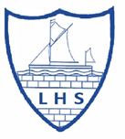

All items are available without the school logo if preferred.
These prices are accurate at time of publication and may be subject to alteration
Order Online at www.forsterskent.co.uk
Full Size Guides available online
Easy and Flexible exchanges - visit website for full details
Forster's are an official stockists of uniform for this school
Forster's is also a stockist of Work Wear, Safety Boots and Health Care Products (Tunics/Scrubs/Facemasks)
We also stock Scout, Cubs, Beaver, Guide, Brownie and Rainbow uniforms

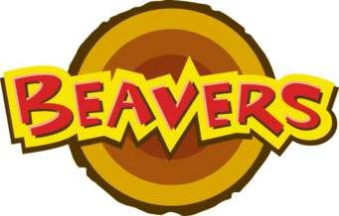
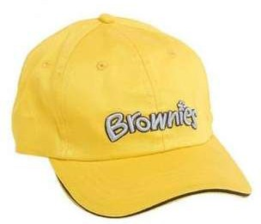
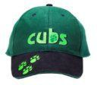
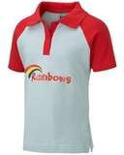


Forster's accept all major credit cards. The uniforms can be purchased online at

www.forsterskent.co.uk

Tel: 01795 472947

