Relationships and Sex Education


Lower Halstow and
Newington CEP Schools
Federation
‘Respect, Honesty, Kindness, Perseverance’

‘Welcoming, Forgiving, Generous, Flourishing’

Created: September 2018

Approved | Team | Review
October 18 | L & D (mail) | Autumn 2021
July 2020 | L & D | July 2023
June 2023 | L & D | Summer 2026
July 2024 | FGB | Autumn 2025

This policy was reviewed early to reflect the new DfE statutory policy guidance.

Rationale and Organisation

At Lower Halstow and Newington CEP Schools Federation we have based our Relationships and Sex Education (RSE) policy on the Department for Education document

‘Relationships Education, Relationships and Sex Education (RSE) and Health Education
Statutory guidance for governing bodies, proprietors, head teachers, principals, senior leadership teams, teachers’ (2019)

Appendix 1 contains a list of other documents which have been used to inform our thinking.

The Federation approach is built on firm Christian principles embracing the ‘Golden Rule’ – to love our neighbours as ourselves. We encourage respect for others, ourselves and our community, both locally and globally. A dedicated team of teachers and support staff, led by the Heads of School and Executive Headteacher, give the children an excellent start at school, modeling positive relationships. Our children thrive in the happy community atmosphere where variety & difference are fully embraced and stereotypes are challenged.

RSE continues to be part of the Personal, Social and Health Education (PSHE) curriculum in the school, as this provides a holistic way of linking experience and ideas across several areas of personal development. The Federation PSHE scheme of work includes age appropriate learning, matching the latest statutory requirements of RSE & health and planned under the five relationship themes in the HeartSmart scheme of work. It also includes additional bespoke PSHE activities following consultation with staff, pupils and parents and taking account of our local context.

Aims

At Lower Halstow and Newington CEP Schools Federation we aim:
- To ensure that pupils are prepared for puberty
- To develop confidence in talking, listening and thinking about feelings and relationships, and respect the differences between people;
- For pupils to be able to name parts of the body and describe how their bodies work;
- For children to know how they can protect themselves and where to ask for help and support;
- To empower children to make informed choices about their education and future adult life.
- To help the children respect their own bodies and understand the importance of sexual activity being within a committed, long term and loving relationship
- To emphasis the importance of family life in all its forms
- To help the children pose and answer moral questions
- To explore relationship issues and how these can be resolved
- To give the children the knowledge needed to avoid sexual abuse /exploitation, and to know where they can seek advice if they are worried about any sexual matters.

While we use RSE to inform children about sexual issues, we do this with regard to matters of morality and individual responsibility in a way that allows children to ask and explore questions. We do not use RSE as a means of promoting any form of sexual orientation or a single view of ‘family life'.

Definition of Relationships, Sex & Health Education – rights with withdraw
Please see appendix 2 for a grid outlining the various aspects of relationships, sex and health education and where this is covered in the curriculum. There is no right to withdraw a child from relationships, health or science education.

Sex Education
Parents have the right to withdraw their child from sex education, but in the Federation we have decided against delivering this directly. This means there are no specific lessons pupils can be withdrawn from.

The year 5 science curriculum covers ‘human life time, gestation, growth of babies and puberty’. The sexual reproduction content below is communicated during the wider science unit on ‘Animals (inc humans) – life cycles’
· Reproduction is adult; requires physical and emotional maturity
· Sperm and Egg are needed to make a baby
· Humans give birth to live young

This potentially falls under ‘sex education’ and if parents wish to discuss this content or withdraw their child they should contact the head of school in writing via the school office.

This science unit may give rise to other questions, which will be forwarded to the child’s parents for a response only if they fall outside of relationships or health education or the science national curriculum. If parents indicate that they are happy for staff to answer the questions then we will endeavour to do so.

The following sexual reproduction content is NOT covered in our curriculum
· Legal age of consent
· Conception (inc IVF)
· Sexual Intercourse

Delivering Relationships and Sex Education
Please see appendix 3 for our guidance document for the delivery of relationships education.

‘Puberty talks’ are conducted in Y5 by school staff who have an existing relationship with the pupils. There are two specific teaching sessions in Term 6. In the first of these, the children are shown a video called ‘Growing Up’ which is shared in advance with the parents. If you would like the latest working link to this video please email either school office and this will be provided. office@newington.kent.sch.uk office@lower-halstow.kent.sch.uk

During the second teaching session, children are given the opportunity to ask questions and discuss matters raised in the video. The children are separated by gender for this session, which is led by appropriate members of staff.

Cross-curricular Links
All curriculum areas contribute to RSE. Some subjects make a clear contribution, such as Science and PSHE, while other subjects make a less obvious, but important, contribution, such as:

- Literacy – discussion of specific relationships and moral dilemmas
- R.E. – discussion of family and marriage traditions
- History and Geography – discussion of wider social issues
- Art and Music – discussion of feelings and emotions within relationships

Working with Parents and Carers

Parents and Carers have an especially important role to play in RSE. They need to feel confident that the Federation’s programme compliments and supports their role. Parents are the key people in teaching their children about sex and relationships; maintaining the culture and ethos of the family; helping their children cope with the emotional and physical aspects of growing up; and preparing them for the challenges and responsibilities that sexual maturity brings. The schools work in partnership with parents.

Working with Outside Agencies

Where visitors are invited to deliver aspects of the RSE programme, they are used to support, not supplant, the role of the teacher and they are always accompanied by a teacher. There are discussions before any input, including on confidentiality issues, and joint evaluation afterwards. Our current programme does not include the use of visitors but our policy allows for this where suitable e.g. a session by a nurse from the school health service.

Differentiation and Special Educational Needs
We recognise that all children have varied life experiences and a range of feelings and attitudes. Lessons allow all perceptions to be articulated, and all contributions are valued and respected.

Teachers may use different resources, activities or provide specific support depending on the needs of the pupils. Teaching points are conveyed using language that is accessible to the pupils.

Specific Issues
The personal beliefs and attitudes of teachers do not influence their teaching of RSE. Teachers answer pupil questions appropriately and using their professional judgement, in line with this policy. There is no expectation that any teacher delivering RSE will automatically answer pupil questions, as this may infringe personal boundaries. However, in this instance, pupils are advised to talk to their parents, another member of staff, or advised as to where they may be able to access information e.g. help lines, websites, leaflets etc.

If a child makes a disclosure that causes the teacher concern, then normal child protection procedures are followed.

Ground Rules
We feel that it is essential that the school assists pupils in developing confidence when talking, listening and thinking about sex and relationships, therefore the following ground rules are set to create a safe environment where no-one need feel embarrassed or anxious about unintended or unexpected questions or comments from pupils. We therefore believe that ground rules are an important process for a class or year group. Basic rules should incorporate the following:

- No-one teacher or pupil will have to answer a personal question.
- No-one will be forced to take part in a discussion.
- Only the correct names for the body parts will be used.
- Meanings of words will be explained in a factual way.

Equal Opportunities
Lower Halstow and Newington CEP Schools Federation is committed to working towards equal opportunities in all areas of school life and upholding the principles in the Education Act 2010. We aim to avoid stereotyping and believe that pupils’ religious beliefs and cultural differences should also be respected.

Monitoring and Review
The Governing body reviews the RSE policy as required, and at least every 3 years. Recommendations are reported to the learning and development committee, as necessary, to update this policy statement. Governors require the Executive Headteacher to keep a written record of the content and delivery of the RSE programme that is taught at Lower Halstow and Newington CEP Schools Federation. This is done by having all lesson planning stored on the shared school drive.

Appendix 3 outline specific arrangements for monitoring the effectiveness of our relationships education.

Appendix one
Other useful documents and guidance used to create this policy

• Respectful School Communities: Self Review and Signposting Tool (a tool to support a whole school approach that promotes respect and discipline)
• Behaviour and Discipline in Schools (advice for schools, including advice for appropriate behaviour between pupils)
• Equality Act 2010
• SEND code of practice: 0 to 25 years (statutory guidance)
• Mental Health and Behaviour in Schools (advice for schools)
• Preventing and Tackling Bullying (advice for schools, including advice on cyberbullying)
• Sexual violence and sexual harassment between children in schools (advice for schools)
• The Equality and Human Rights Commission Advice and Guidance (provides advice on avoiding discrimination in a variety of educational contexts)
• Promoting Fundamental British Values as part of SMSC in schools (guidance for maintained schools on promoting basic important British values as part of pupils’ spiritual, moral, social and cultural (SMSC)

Appendix 2
Defining Sex education and rights to withdraw
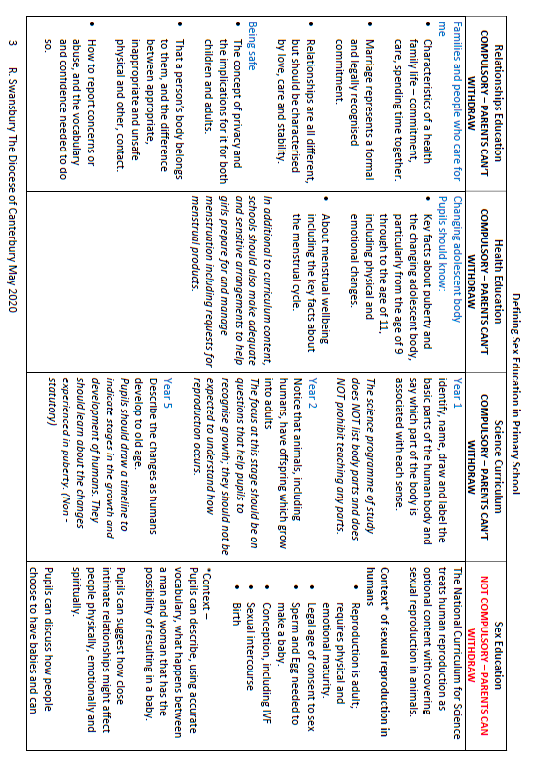

Appendix 3
Relationship Education Delivery Model and Evaluation Arrangements

Relationships Education
Relationship education in primary school teaches children the fundamental building blocks and characteristics of positive relationships, with particular reference to friendships, family relationships and relationships with other children, adults and the wider community.

Vision and Values
At Newington, our Christian vision is for our children to realise their God-Given potential which necessitates the essential ability to form positive relationships in the modern world. Our values particularly encourage children and adults to be welcoming and forgiving, as well as generous to others in school, the local community and the wider world.

At Lower Halstow, our Federation Vision includes ‘happiness and co-operation’ and our values include respect, honesty and kindness, with a focus on how we show these in all our interactions.

Experiential learning at both schools provides the children and their families with a range of opportunities, challenges and responsibilities, including within this ‘relationships with other people’.
There is an emphasis across the federation on providing strategies to sustain healthy relationships and know how to deal with and recognise when and how relationships go wrong.

Scheme of Work
The following Relationships Education topics are taught through the scheme HeartSmart

- Families and people who care for me
- Caring friendships
- Respectful relationships
- Online relationships
- Being safe

This includes a resource toolkit for resilience, well -being and healthy relationships. The scheme includes all year groups from EYFS to Year 6 and is a graduated age-appropriate programme.
5 HeartSmart Principles developed through each year group.
- Don’t Forget to Let Love in! – learning how important, valued and loved we are.
- Too Much Selfie isn’t Healthy! – exploring the importance of others and how to love them well.
- Don’t Rub it In, Rub it Out! - Understanding how to process negative emotion and choose forgiveness to restore relationships.
- Fake is a Mistake! - Unpacking how to bravely communicate truth and be proud of who we are.
- ‘No Way Through’ Isn’t True!- Knowing there is a way through every situation, no matter how impossible it may seem.

Delivering Relationship Education
- Relationship education will be planned termly by class teachers including Heartsmart units and stand-alone lessons or experiences taken from the PSHE scheme of work.
- EYFS will integrate Heartsmart units with the Prime Area of learning - personal social and emotional development.
- Teachers will work from the relationship education topics on a one-to-one basis or in small groups as necessary and appropriate, particularly linked with School and/or Federation values.
- Experiential learning will give pupils opportunities to form healthy relationships and recognise positive emotional and mental wellbeing.
- Relationship education will be delivered in a sensitive and well-judged way based on knowledge of pupils and their circumstances, including children with special educational needs or disabilities.
- Relationship education will be implicit in all online learning.
- The use of visitors will be to enhance learning and will be arranged by a member of staff following the protocols for working with outside agencies.
- Staff will take any issues or concerns beyond those set out in the relationships education curriculum to SLT or FLO.

Monitoring and Evaluation
The PSHE subject leader will oversee relationships education. This will include remote monitoring inc planning, pupil voice. Termly SEMH audits will capture a developing picture of pupils’ relationship with themselves and others. This information along ith feedback from our ELSA/Well-being TA is used to evaluate the effectiveness of relationships education.
The right to withdraw
There is no right to withdraw from Relationship Education.

